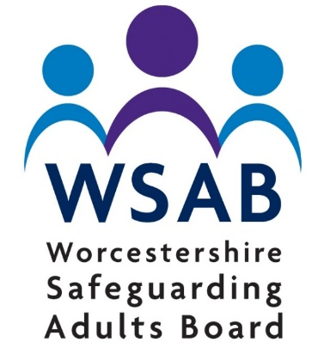
Newsletter
  - October 2019

Annual Learning Event
The WSAB Annual Learning Event will take place on Friday 15th November 2019 and as usual will focus on a theme of learning from Safeguarding Adults Reviews (SARs). For further details and to book a place please click on the link Eventbrite - WSAB Annual Learning Event - Tickets.

Board Documents
Documents which have been published or revised this quarter include:
The WSAB Annual Report for 2018/19: WSAB Annual Report-2018-19/
An update of the Escalation Policy: WSAB Escalation Policy
A revised information sharing protocol so that it has the same expectation and requirements as the Children's Partnership: WSAB Information Sharing Protocol

Network Group
The Adults Safeguarding Network Group meeting took place on the morning of 24th October 2019. This group was open to organisations who directly deliver services to adults at risk, including voluntary sector and services that operate at a district level. The purpose of the group is to share information about Safeguarding and look at how to address issues which don't meet the Section 42 criteria.
The October meeting looked at the introduction Liberty of Protection Safeguards and how to address Self Neglect cases through a strength based approach. For more information contact Sarah Wilks at: swilks@worcestershire.gov.uk
A Task and Finish group from this Network have produced a simple survey to enable us better understand the current level of safeguarding training within the voluntary and community sector in Worcestershire. By identifying the training needs it is hoped that this task and finish group will be better able to co-ordinate and share training across the sector. It also provides an opportunity to identify any gaps which can be addressed in the development of future training.
Below is the link to the survey, It should only take you approximately 4 minutes to complete!
we would be grateful if you could complete it by 15th November.
https://www.surveymonkey.co.uk/r/8TZ3DSJ

Board Update
The Worcestershire Safeguarding Adults Board met in September. At this meeting the Board agreed to commission a piece of work to complement the development of the Get Safe initiative. The Get Safe work is being led by the Children's Board and seeks to develop an approach for addressing trafficking and modern slavery. The work commissioned by the WSAB will explore how adults with care and support needs can become at risk of being exploited in this way.
The Board also agreed to revise its Annual Self Assurance approach. Existing assurance frameworks which individual organisations complete had been assessed and it was agreed that these were sufficient for ensuring that the Board met its requirements, as set out in the Care Act.

Work of the Subgroups
Case Review – are managing a large workload which currently includes three Safeguarding Adults Reviews (SARs), work on SAR Quality Markers and the ongoing monitoring of a number of SAR Action Plans.
Thematic Safeguarding Adults Review on Rough Sleepers
The Board is also about to begin a thematic SAR looking at the experience of Rough Sleepers. A stakeholder event is to be held on 7th November. If any organisations that have an interest in working with this group of people would like to attend this event please contact the Board at SafeguardingAdultsBo@worcestershrie.gov.uk
Communications – are continuing to develop the content and layout of the new website, as well as supporting the publication of some new and updated policy and guidance documents.
Over the last twelve months this sub-group has been chaired by the Board Chair; however we are pleased to announce that this role will now be taken over by the Communication Lead for the Clinical Commissioning Group.
Performance & Quality Assurance – are monitoring the progress of multi-agency actions associated with SARs and have now developed an audit programme. The first audit examined the application of Making Safeguarding Personal in Safeguarding reporting. It looked at a random selection of referrals to see whether the person referring had taken account of the person's wishes and views as part of the process.
Learning, Development & Practice – the Worcestershire Safeguarding Adults Competency Framework is under review along with the Boards Training strategy. There is also some collaborative work under way to develop a guidance document for professionals who are concerned about individuals who are hoarding.

Website
For further information on the work of the WSAB please go to our new website https://www.safeguardingworcestershire.org.uk/

