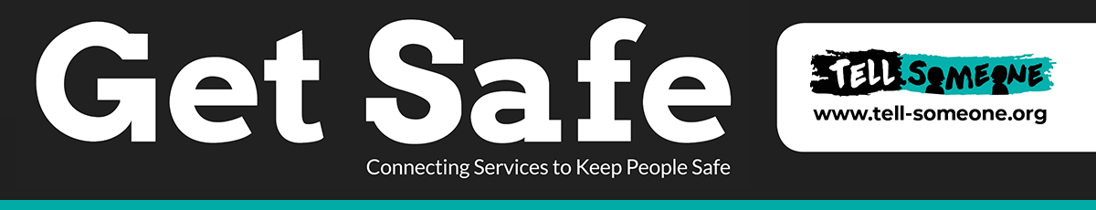

**The GET SAFE Multi Agency response Pathway**

| **RED Level 4 Needs** | **AMBER Level 4 Needs** | **Green Level 3/2 Needs** |
| --- | --- | --- |
| Open to Childrens’ Social Care and potentially Youth Justice Team | Open to Childrens’ Social Care and potentially Youth Justice Team | These will be young people who require an Early Help Assessment and lead agency |
| Will be identified as **RED** on the Multi Agency GET SAFE Data set | Will be identified as **AMBER** on the Multi Agency GET SAFE Data Set | The young person will be added to the GET SAFE Data set as **GREEN**  Young people whereby there is no evidence of get safe concerns or vulnerability will not be overseen by GET SAFE Team and will not be added to GET SAFE Data. |
| Can be on single incident or an accumulation of incidents/notifications over a condensed period of time that are high risk to the young person and identify them as being criminally exploited. | Can be on single incident or an accumulation of incidents/notifications over a condensed period of time which are of concern in their frequency/ pattern and impact on the young person. These young people maybe being criminally exploited or need further assessment / direct work to establish their risks. | These young people are identified as having contextual safeguarding concerns that suggests vulnerability to criminal exploitation specifically. There is no evidence identifying them as being exploited but further direct work and an early help assessment and plan is required. |
| These young people will be open and allocated to a Social worker and have a plan in place. This maybe:  CIN GET SAFE Plan  Child protection Plan  Children Looked After Plan  And a Youth Justice plan of intervention. | These young people will be open and allocated to a Social worker and have a plan in place. This maybe:  CIN GET SAFE Plan  Child protection Plan  Looked After children Pan  And a Youth Justice plan of intervention. | These young people need to have an Early help assessment and plan put in place.  The Early Help Pathway will be followed for this young person as this pathway is a preventative diversionary pathway. Therefore these young people will have a Early help 4 P plan.  Any agency can be the lead agency and seek support from partner agencies in the diversionary work required to build safety and support to the child and disrupt any risks identified in the GET SAFE initial risk assessment. |
| Police and children’s Social Care with Youth justice (where applicable) will be joint lead agencies for the young person.  A 4 P multi agency plan will be in place to address the GET SAFE concerns for this young person. | Police and Children’s Social Care with Youth Justice (where applicable) will be joint lead agencies for the young person.  A 4 P multi agency plan will be in place to address the GET SAFE concerns for this young person. | The Multi agency GET SAFE Team will monitor the status of these young people and revaluate any repeat GET SAFE initial risk assessments provided. |
| The GET SAFE MACE meetings will review the 4 P Plan in terms of the impact and outcomes it is achieving in addressing and reducing the risk to the young person.  The emotional well-being and support to this young person needs to be formulated in the 4 P Plan.  Alongside support to the young person’s parents or carers where the young person resides within their family network.  Where a strategic response is need to a block or access of specialist resource or targeted response that cannot be achieved at practitioner level then the case will be presented to the GET SAFE operational group for assistance and action. | The GET SAFE MACE meetings will review the 4 P Plan in terms of the impact and outcomes it is achieving in addressing and reducing the risk to the young person.  The emotional well-being and support to this young person needs to be formulated in the 4 P Plan.  Alongside support to the young person’s parents or carers where the young person resides within their family network.  This Multi-agency forum will also identify increased / decreased risk and action this as appropriate but inform the weekly GET SAFE multi agency meeting of the changes.  The Multi Agency GET SAFE will review the RAG Status of the child. | The GET SAFE Team will consider the information in the GET SAFE initial risk Assessment and decide if the young person meets the criteria for:   1. The diversionary network 2. Missing Monday’s meeting |
| The GET SAFE Multi agency Team will consider the need for specialist work from:   1. BRANCH (CSE) 2. The GET SAFE direct work worker 3. Specific needs | The GET SAFE Multi agency Team will consider:   1. The direct work from the diversionary network 2. BRANCH (CSE) 3. The GET SAFE direct work worker | MACE meetings will not be required for this cohort f young people.  A community-based response will be considered id specific hot spots are identified for young people in an area or school environment using the contextual safeguarding model. |
| Children placed in Worcestershire by another LA will follow that LAs Care Plan – copies will be requested by the GET SAFE requested by the GET SAFE Team so local responses can be clear. | Young people placed in Worcestershire but on the responsibility of another LA will be added to the data set but will follow that LA’s Plan. Copies of this will be sought from that LA be sought from that LA by Worcestershire’s GET SAFE Team to inform Local responses | Where a young person has not had any additional concerns in the last 3 months then their entry onto the Get Safe Data base may be removed if they are not receiving direct work or intervention around GET SAFE concerns. |