GET SAFE

Child Exploitation Risk Assessment
The information given throughout this form must be typed.

To support you in completing this GET SAFE risk assessment please use the GET SAFE Practitioners guide:

Language is extremely important when we talk about children who are victims of harm and abuse through exploitation and therefore the following guidance will assist you in how you describe events and risks in this assessment form :Appropriate Language – Childrens Society Guidance for Professionals

If you have intelligence about a location and / or suspected perpetrator(s) then this can be shared with the police by completing the attached and sending this directly to the e-mail address supplied in the document:
Please note this is an external document owned by the police

Child’s details
Child’s Forename: | Child’s Surname: | D.O.B.
Address: | Disability / additional needs:  Education Health Care Plan Y / N | NHS Number: (if known)  GP Practice (if known)  Education UPN:
Ethnicity: | Gender: | Religion:
Name of professional completing this Risk Assessment:  Agency:  Email address:  Telephone number:  Relationship to the child e.g. DSL, Dr, Social worker: | Child’s current plan of support where known  Early Help plan:  Child in Need plan:  Child Protection plan:  Child Looked After Care Plan:  If the child is subject to a plan, who is the child’s responsible Local Authority? ……………………………. | Education / training or employment  Name of establishment:  Or  Elective Home Educated (EHE)………………….  Child Missing in Education (CME)……………………  Not in Education employment or training (NEET)…………………………  Not known…………………………  NB: Attendance at school/college can be addressed further on in this assessment tool.

Consent
CONSENT  Has the child given consent to the completion of this Risk Assessment?  YES (tick)  Please record any views/comments of the child…………………………………….  NO (Tick) if no please state why………………………………………………….. | Have parents/ carers given consent to the completion of this Assessment?  If no, (tick) please state why they have not been informed: ……………………………  If Yes, please state any comments or views ………………………………….  Please record any views of both parent/carers.

Diagram:
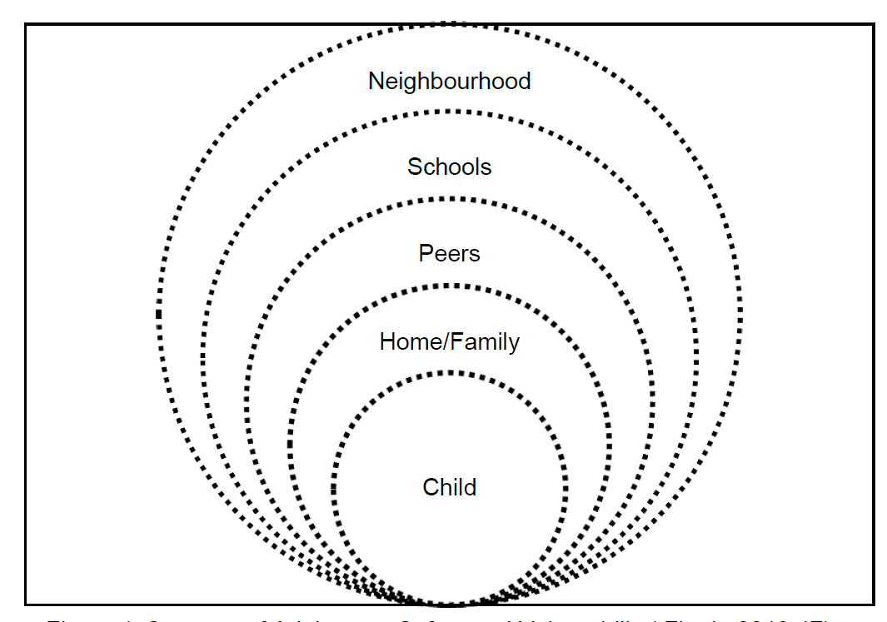 | Child  - Persistently going missing from school or home. Unexplained acquisition of money, clothes, or mobile phones;  - Health concerns  - Change in behaviour  - Radical thoughts  - Change in physical and/or emotional presentation that are not age appropriate/out of character  Home/family  - Regularly leaving their home without explanation.  - Recent negative change in quality of relationships at home  - Poor or negative communication with young person not responding to boundaries, routines or consequences  - Culture  - Expectations of family  - Neglect  - Domestic Abuse  - Parental Capacity  - Parents offending /prison | Peers  - Relationships with controlling / individuals or groups. Peers who are using illegal substances  - Peers who are known by criminal justice agencies  - Spending more time with peers in the community/whereabouts unknown  - Peer group violence/ sexual offending  Schools  - Significant decline in educational attainment and attendance.  - Bullying  - NEET.  - Special Educational Needs  - Exclusions/Alternative Educational Provision  - Peer recruitment.  Neighbourhood  - Public Transport – use of  - ASB, Criminal Behaviour  - Gangs / Risky Adults /Locations  - Parks, shopping centres, areas of concern.

The information given throughout this form must be typed.

Protective Factors for this child
Using the Contextual Safeguarding model above please detail the factors you have identified or those known to you in relation to this child that could indicate that they may be at risk of child exploitation or are being exploited.

Child | Home/Family | Peers | Schools | Neighbourhood

Considering the areas of this child’s life, what are you most concerned about in each of these areas?

Child | Home/Family | Peers | Schools | Neighbourhood

What is the most concerning recent example of child exploitation you have had for this child?

What is the current impact of the above GET SAFE concerns on these areas of this child’s life? How do they affect the child from engaging, functioning, attending, staying safe etc.
Child | Home/Family | Peers | Schools | Neighbourhood

What strengths and protective factors can you identify that exist and can be built upon to engage and disrupt the exploitation. Please include and identify what you or your agency are already doing or planning to do.

What’s working well? What are the strengths and protective factors around this child? | What needs to happen? What could disrupt the abuse or harm? What could support the child and their family?

Please provide details of agencies to your knowledge that are involved with the child/family or pending referrals.

Agency | Details if involved with child/family
CAMHS /Mental Health Support
The Branch Project / WMRSASC
YSS
Additional Education Support
Sexual Health
Youth Justice Service
Early Intervention Family Support
Targeted Family Support
Any other agency or community support known?

Child exploitation concerns

Based on the information you have provided in this assessment what forms of child exploitation are you concerned is/are happening to this child ?
Tick any of the following below you are concerned about

Gangs |  | Trafficking
Sexual Exploitation |  | Modern Slavery
Criminal Exploitation |  | Absent or missing
Radicalisation |  | Forced marriage
Female Genital Mutilation (FGM) |  | Honoured Based Violence
None Identified

Child Exploitation Risk Assessment
Based on the factors you have identified, please indicate your professional opinion as to the level of risk this child faces: | Evidence of vulnerability to child exploitation (Low)  Evidence of being groomed or targeted for the purposes of child exploitation (Medium)  Evidence that the child is being exploited. Please describe the type of exploitation e.g. Sexual, Criminal, Forced Labour (High)  Please ensure that you have included all the known information about this child to support your agency’s analysis of risk.
Considering all the information you have captured about this child can you please provide us with your professional opinion on how you have determined this child to be at low/medium/high risk of child exploitation:
Please ensure that this has been discussed with your agency’s safeguarding lead for advice and support. | AGENCY SAFEGUARDING LEAD NAME:  DATE child discussed:

WHAT DO YOU NEED TO DO NEXT
This is not a referral to Children’s Social Care. If you have an immediate concern about the safety and welfare of a child please phone the Family Front Door directly on 01905 822666 for advice or Out of Hours Emergency Duty Team on 01905 768020 and/or Police where appropriate.
If the outcome is that, in your professional opinion, the child is NOT vulnerable to or experiencing exploitation there is no need to submit this form to the multi-agency Get Safe Portal. You may need to consider an Early Help Assessment to address the concerns identified and safeguard the child. It is recommended that this form is saved by your agency should further concerns arise to enable you to review this risk assessment.
If you have identified that the child IS VULNERABLE to exploitation, then please submit the Risk Assessment via the Multi Agency Get Safe Portal and with your agencies safeguarding lead you may need to consider an Early Help Assessment to address the concerns identified and safeguard the child.
If the outcome is that, in your professional opinion, the child IS EXPERIENCING exploitation then you must complete a referral to Worcestershire’s Children’s Social Care AND submit the Risk Assessment via the Multi Agency Get Safe Portal.

GET SAFE Links for professionals completing this risk assessment:
- GET SAFE PORTAL
- Early Help Web Page website
- Referral to WCC GET SAFE

Please submit this form where appropriate once fully completed to the Multi Agency GET SAFE Portal.
This information will be shared with the multi-agency GET SAFE Team they will identify the outcome and appropriate pathways of help and support this child needs where there is GET SAFE concerns. The outcome will be shared with you within 5 working days of the multi-agency meeting which is every Tuesday.
This is not a referral to Children’s Social Care. If you have an immediate concern about the safety and welfare of a child please phone the Family Front Door directly on 01905 822666 for advice or Out of Hours Emergency Duty Team on 01905 768020 and/or Police where appropriate.
GET SAFE MEETING:
Date of Multi Agency GET SAFE Meeting:  Response to Referrer: | Outcome of the Multi Agency Get Safe Meeting:  RED Pathway:  Amber Pathway:  Green Pathway:  NFA by GET SAFE as no GET SAFE concerns identified advice given:  Level of need identified (level 2/3) Early Help Assessment required by Lead Professional:  Referral to Children’s Social Care needed (Level 4 concerns):
Date of response to referrer. | Date of this outcome:

