Safeguarding Adult Review (SAR) Referral Form and Decision Record

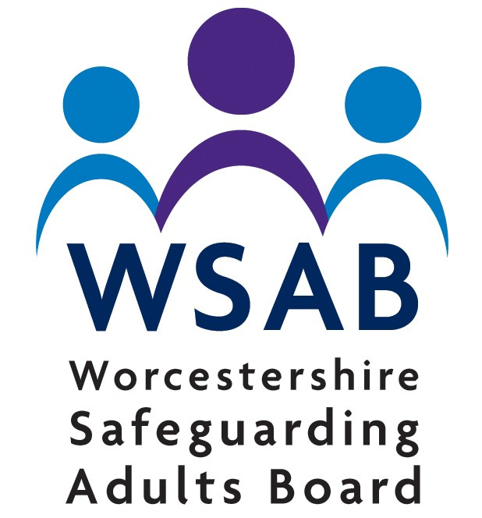
This form should be completed to make a SAR referral and forwarded to the relevant Safeguarding Adults Board

Which Board do you want to refer to? | Worcestershire Safeguarding Adults Board

The responsible Safeguarding Adults Board will consider every referral on the basis of whether it meets the Safeguarding Adults Review criteria as stipulated in section 44 of the Care Act 2014 which states:

- A Safeguarding Adult Board (SAB) must arrange for there to be a review of a case involving an adult in its area with needs for care and support (whether or not the local authority has been meeting any of those needs) if:
  - There is reasonable cause for concern about how the SAB, members of it or other persons with relevant functions worked together to safeguarding the adult

And
  - Either of the following conditions are met –
- Condition 1 is met if –
  - The adult is still alive, and
  - The SAB knows or suspects that the death resulted from abuse or neglect (whether or not it knows about or suspected the abuse or neglect before the adult died)
- Condition 2 is met if –
  - The adult is still alive, and
  - The SAB knows or suspects that the adult has experienced serious abuse or neglect.

Further information about Safeguarding Adult Reviews can be found within the local Safeguarding Adults Board protocol and supporting documents.

A SAR will not blame any organisation or person for something that has not worked well. It is not an alternative to a complaint. The SAR process looks at whether any lessons can be learned about the way organisations worked together to support and protect the person who died or suffered harm.

How can I refer a case for review?
- Any professional can make a referral. If you know of a case that meets the SAR criteria, then you should first discuss a possible referral with the safeguarding lead for your organisation.
- A member of the public that wishes to make a referral should contact the worker involved with the person's care to discuss the circumstances. The worker will then assess whether there is sufficient evidence to make a referral on their behalf.
- Cases that have the potential for a SAR and notification of any single agency reviews should be referred immediately.
- Referrals should be quality assured and authorised by your agencies Safeguarding Lead or a Senior Manager prior to submission.
- All referrals must be submitted securely. Please contact the local SAB to discuss as required.
- Referrals will be considered for a review and the referrer informed of the outcome.

Section 1 – TO BE COMPLETED BY THE REFERRING AGENCY

Please complete all sections and include as much information as possible to ensure that the decision-making process is robust and proportionate.

This document contains sensitive personal data so please ensure your email is secure or encrypted.

1. Details of person making referral
Name
Position
Agency
Address
Phone Number
E-mail

2. Details of the person being referred
Name
Date of birth
Date of death (if applicable)
Inquest date (if known)
Address
Care and support needs/significant medical information

3. Details of the representative/family of the adult with care and support needs
Does the adult have any family or representative as far as you are aware?
Are they aware of the SAR referral?
Family member/representative contact name
Relationship to the adult
Phone number
Address
Is there any reason the family should not be contacted if a decision is made that the case meets the criteria for a SAR? | (if Yes please give details)

4. Notification of other reviews being undertaken
Domestic Homicide Review (DHR)
Multi Agency Public Protection Arrangements (MAPPA) review Root Cause Analysis (RCA)
Child Safeguarding Practice Review Learning Disabilities Mortality LeDeR Review Other

Date review commenced:
Date review completed:
Please provide details including recommendations where known:

5. Please provide a brief summary of the case and the circumstances that led to the referral including any practice issues identified.
Please include details of; victim (age, gender, ethnicity), the care and support needs, living situation, location of the abuse/incident, type of abuse/safeguarding issue, and who the source of risk is.

6. Please outline the factors that suggest the SAR criteria are met:

Please refer to the front page of this referral form and include in detail how you feel the circumstances meet the criteria for a Safeguarding Adults Review responding fully to each separate criteria.

For the circumstances to meet the criteria there must be concerns about how separate agencies worked together.
a) The adult has care and support needs/significant medical information – Specify below:
b) There is reasonable cause for concern about how the SAB, members of it or other persons with relevant functions worked together to safeguard the adult. Specify below:
c) The adult has died (suspected to be resulting from abuse or neglect). Specify below:
d) The adult is still alive and suspected to have experienced abuse or neglect:

7. Please list the agencies/service providers known to be involved in this case. Please include the GP

8. Please provide any additional information you feel is relevant.
.

The Safeguarding Lead for your agency should sign below to confirm that they are in agreement for this referral to be made to the SAB.

9. Please account for any delay in the referral being submitted.
N/A

Signed: ………………………….. Print name: …………………….. Senior Manager/Designated Safeguarding Lead/SAB Member

Date Authorised: ………………………………..

Reason for referral without authorisation (if applicable):

Section 2
TO BE COMPLETED ON BEHALF OF THE SAFEGUARDING ADULTS BOARD

2a Record of where a Request does not meet the SAR criteria and is being closed without scoping

Date | Decision made by | Decision/comments
Expands to fit | Expands to fit | Expands to fit

2b Record of Discussion/s at the Scoping Meeting

Attended by:
Name | Title & Organisation

Date | Discussion  (including consideration of the factors highlighted for consideration within the Quality Markers) | Decision
Expands to fit | Expands to fit | Expands to fit

Agencies who have not responded to the request for information and action taken:

After reviewing the information from all involved agencies, it is recommended that this case:
i | Meets the criteria for a SAR under S44 (1) and (2) or (3) of The Care Act 2014
ii | Meets the criteria for a SAR under S44 (4) The Care Act 2014
iii | Does not meet the criteria for a SAR under S44 The Care Act 2014

Recommendation to SAB Chair

It is recommended/not recommended that this case is subject to a SAR for the following reasons (include rationale for recommendation and consideration of MSP, information on key areas of enquiry, methodology and timeframe):

If the case does not meet the criteria for a SAR and another review process has been agreed, please give details below (please refer to the guidelines):

Please account for any delay in decision making:

Signed: ..................................................................
Scoping Meeting Chair

Date: ...................................................................

SAB Chair Decision

Signed: ..................................................................

Date: ...................................................................

