Background  A Safeguarding Adult Review (SAR), is a statutory review.  When a SAR is undertaken a Review Panel will be established. The role of a Review Panel is to agree the terms of reference, consider all data being submitted before the Panel, consider the findings and conclusions, and make recommendations in relation to what action is required to address the learning identified.  During the SAR process, practitioners who were directly involved with the Adult (s) will be asked to participate in a Learning and Reflection Workshop (s) facilitated by the Author, to highlight where practice worked well and aid the learning and improvement process to form a first draft. However, it is not essential if you have not been involved with the case and it is understood if this is not possible.  A statutory review is a forum for formal information sharing and all members of the Review Panel will be expected to critically analyse all the information presented.  The Review Panel will consider, amend as necessary and finalise the Report prior to its submission to the Case Review Subgroup.  The Case Review Subgroup will consider, amend as necessary and ratify the Report prior to its submission to the WSAB for further ratification and sign off.  Once recommendations and action plan (s) are agreed it will be the responsibility of the relevant WSAB Subgroup to monitor the implementation of action plan (s).  N.B. Whilst the report remains confidential, there is an expectation that an organisation’s Executive/Director (depending on the governance arrangements in place in a particular organisation), will have had sight of the unredacted report and will have been informed by the Panel member of any Organisational concerns or learning as they emerge during the review. |  |  | Panel Member & Practitioner Responsibilities During a Safeguarding Adult Review (SAR)  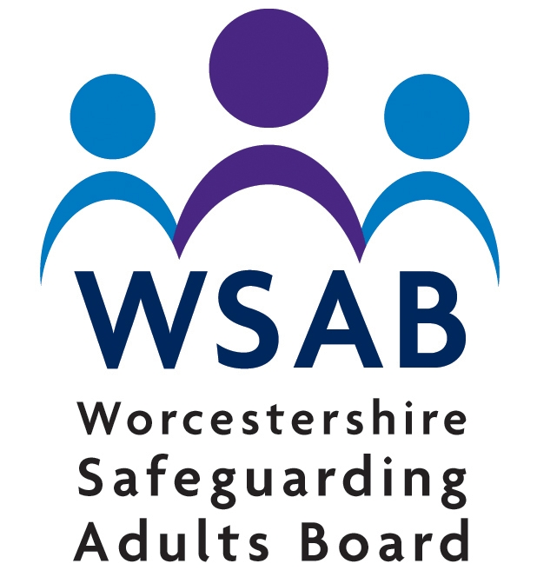  Worcestershire Safeguarding Adults Board  - (WSAB)
Page 4 Page 1
Panel member responsibilities  Each Panel member has a key role and professional responsibility within the statutory Review process. Agencies must be robust in selecting their nominated panel member and be clear on time commitment.  As a Panel member, attendance at and thorough preparation for each Panel meeting is expected. The nomination of any deputy is only permitted under exceptional circumstances. Continuity is crucial to the process.  Each Panel member must be of requisite seniority to be able to fully secure their organisation’s full participation in the Review. This includes supporting the Panel Chair to convey any urgent learning points emerging from the review while it is in progress.  The panel member must not have been directly involved in the first line management or frontline care of the individual (s) concerned.  The Panel members will undertake an assessment of good practice, what might have been done differently or better and recommend how to embed this learning into practice or procedures.  The Review Panel will support the Independent Author to formulate and then finalise recommendations as part of the Report which will indicate:  - What action is required to meet each recommendation  - Who will be responsible for the various actions  - The intended outcome of the various actions and recommendations  - The means of monitoring and reviewing intended improvements in practice and/or systems |  |  | Practitioner responsibilities  It is expected that the Panel member from your organisation would have had a discussion to inform you, the practitioner, of the reasons for the review and the process.  The Safeguarding Adult Review (SAR) enables practitioners and managers to have a constructive experience of taking part in the review to seek essential learning and not to apportion blame.  The practitioner experiences are central to the review for the appropriate learning to be identified.  The role of the workshop enables you the opportunity to develop and shape future good practice based on your experience.  Each Practitioner nominated is ideally expected to have had direct involvement with the Adult (s), however this is not essential.  Each Practitioner is expected to attend (exceptional circumstances must be discussed with your line manager or relevant panel member if you cannot attend) the Learning and Reflection Workshop (s) and fully engage in a first-hand collaborative process in order to gain maximum learning from the Review in order to:  - Enhance partnership working  - Improve outcomes for adults and families  - Prevent similar abuse and neglect in the future  Prior to the workshop it is expected that the nominated practitioner would have familiarised themselves with the case files. Each Practitioner is expected to fully consider and comment on draft version/s of the report issued to them.  Priortit
Page 2 Page 3

