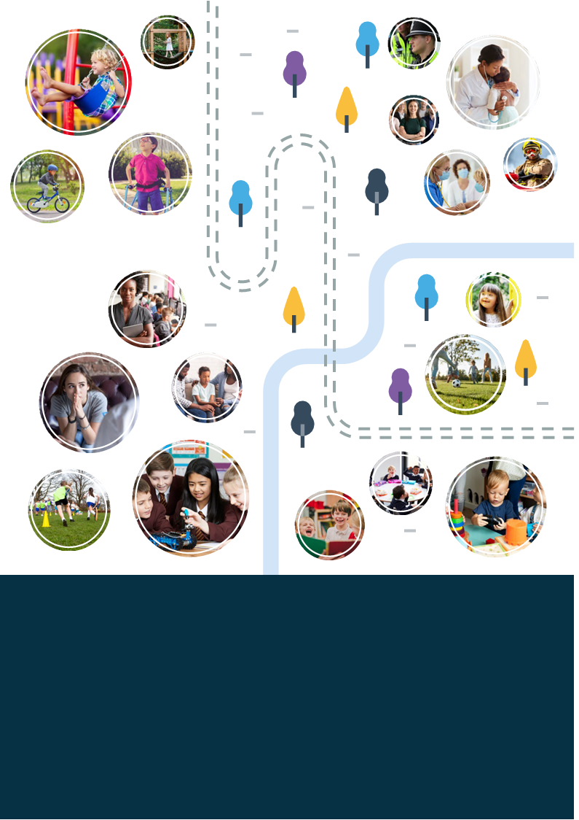
Worcestershire Early Help Strategy
2022-2025

Contents
1. Introduction 2
2. What is Early Help? 3
3. Our ambition for children and young people in Worcestershire is: 4
The Early Intervention Foundation states: 4
4. Worcestershire’s Early Help strategy aims: 5
5. Our Worcestershire Early Help principles: 5
6. Early Help partnership collaboration and co-production 7
7. Our key priorities for 2022 - 2025 8
8. Governance and accountability 9
APPENDIX 1 – Glossary of terms in Early Help: 10

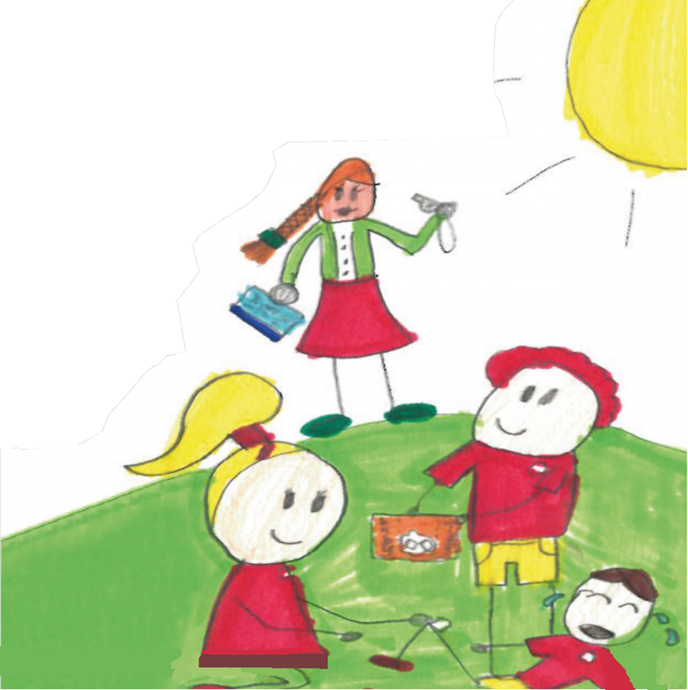

Introduction

This document outlines the Worcestershire Early Help Strategy for how the partnership will work together to help and support children, young people and families living in Worcestershire. We all recognise the need to work collaboratively together to improve the lives and outcomes for children and young people whilst supporting the adults in their lives who care and support them.
In this strategy we recognise the far-reaching impact of Covid 19 and how this has affected children and young people, their families and has changed the lives and needs of our communities.

Why do we need an Early Help strategy?
Working together 2018 states that “local organisations and agencies should have in place effective ways to identify emerging problems and potential unmet needs of individual children and families. Local authorities should work with organisations and agencies to develop joined up Early Help services based on a clear understanding of local needs. This requires all practitioners including those in universal services and those providing services to adults and children, to understand their role launched in identifying emerging problems and share information with other practitioners to support early identification an assessment”. (page 13 Working together 2018)

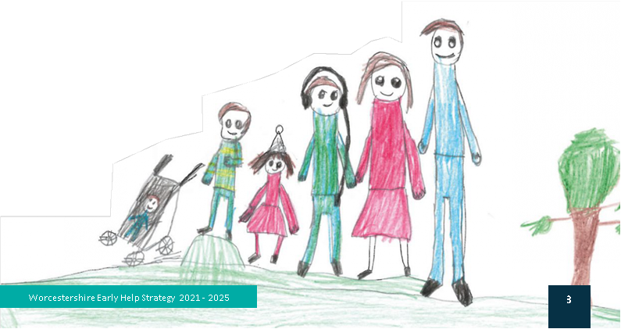

What is Early Help?

Early Help is about identifying needs within families early on, in proactively offering preventative support before the problems become more complex or entrenched. Those coming into contact with families all have a responsibility towards identifying emerging needs as early as possible and responding to them.
Support can be offered early in life or early on in the identification of a particular need which can arise at any point throughout childhood and adolescence. Early Help and support is available for families in Worcestershire with children and young people aged 0 to 18.
Early help is everyone's responsibility, and it requires all those that come into contact with children, young people and their families to understand their role within Early Help. Furthermore, the statutory guidance from Working Together to Safeguard Children (2018) identifies that Early Help requires agencies to work together in order to effectively identify families in need of Early Help support and provide the appropriate support if required. National research and evidence suggest that an early response is a more effective and efficient way of delivering services to children and young people. It is better for children, young people and their families for us to provide help and support when problems first emerged, rather than delivering a more costly statutory intervention when the needs have escalated. This includes using services to reduce or prevent specific problems from getting worse or becoming entrenched. By working together in partnership to deliver an Early Help offer we aim to reduce the demand upon our specialist and higher tier services e.g., hospital admissions, police and ambulance call outs, mental health services, alternative educational provisions, adults and children’s social care, prisons, youth justice remand centres, courts etc. This is in children and young people’s best interests now and later in life.
.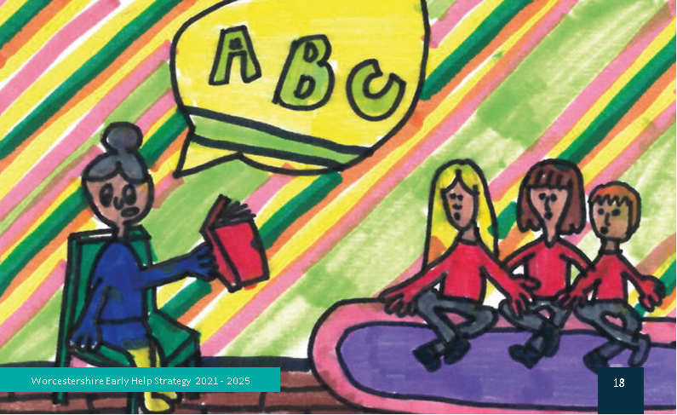

Our ambition for children and young people in Worcestershire is:

- Keeping children safe from harm (at home and in their communities)
- Being healthy
- Enjoy and achieve through learning
- Prevention of crime and serious youth violence
- Promote positive emotional health and wellbeing
- Children and young people achieving their full potential and are supported through to adulthood.

Children, young people, and their families know where to go or who to talk to for help and support in Worcestershire and can access this in a range of ways e.g., online, over the phone, or via their local community workforce at a time when they need it. We recognise the diverse needs of our communities and take account of this when planning and delivering services for children and young people.
We want to provide the best range of services and support to children and young people which is easily accessed and understood ensuring children get the right service at the right time in their local communities.
We want to help and support children and young people to achieve their best and support those caring for them to do this.

The Early Intervention Foundation states:
Every year, children across the UK failed to meet developmental milestones such as gaining a healthy weight and learning to speak, play and interact with their peers at an age-appropriate level. Later down the line, some young people experienced severe difficulties such as engaging in youth violence, developing mental health issues, being taken into care or being excluded from school.
There is clearly a need for early intervention. We know it is possible to make a difference for children and adolescents by preventing problems before they escalate enhancing their ability to navigate life challenges. We want every child to grow up into well-functioning, happy and healthy adults.

Worcestershire’s Early Help strategy aims:
- Ensure we provide a whole family approach
- It is inclusive and diverse for children and young people.
- Children and young people achieving their full potential and are supported through to adulthood.
- Children, young people and their families are supported to make and sustain positive changes in their lives.
- It promotes and supports children and young people being ambitious in what they can achieve and become.
- It delivers a joined-up partnership approach to help and support.
- It focuses on the right support at the right time.
- The partnership workforce is engaged and proactive in its delivery.
- It supports covid recovery for children and young people
- It ensures there are measures of effectiveness, impact and outcomes for children and young people.
- It supports and is integrated within the work of wider strategies for children and young people in Worcestershire.

Our Worcestershire Early Help principles:

Early years help and support in the first five years of life, it is an investment that can pay back for a lifetime and offers a chance to break into generational cycles of poor outcomes. Early Help can help children and young people to develop the skills they need to live happy, healthy, and successful lives. It can improve the quality of children's home lives and family relationships; increase educational attainment and support good mental health.
Children and families at the centre of what we do: Our workforce will focus on the quality of relationships with, and the quality of life for, families, not just managing risk and reducing harm. It means constructive partnership working between organisations voluntary schools’ communities’ children and families to provide personalised integrated whole family approach to support and making every relationship and contact count.
Families and communities can deliver Early Help. Early Help has the best chances of success where individuals and their families feel supported to find their own solutions to the issues facing them. This help often comes within the family or community, and much earlier than help from the statutory services.
Our Contextual Safeguarding approach helps us to understand and respond to wider risks that children and young people face including online, with their peers and in their communities.
Tackling the causes not symptoms. Sustainable positive change for children and their families depends upon preventing and tackling the causes of problems rather than seeking to deal with the presenting symptoms. Early Help and support attempts to identify and prevent the emergence or worsening of family challenges. The signs of safety approach is used in Worcestershire in our work with families, engaging them in identifying their strengths and what their worries and concerns are and what needs to happen next. Recognising that families often have their own ideas and solutions to the challenges they face.
Early Help in Worcestershire is delivered in line with our Worcestershire levels of need guidance: Levels of Need Guidance (formerly Threshold Guidance) | Worcestershire County Council.
The continuum of need helps us to recognise the changing needs of children and young people. For most children and young people in Worcestershire they will only ever need to access universally available services such as education and health care, (level 1 needs, universal services). But for some children and young people their needs will be different e.g., children with mental health or disabilities or change over time with help and support. The continuum of need is a model used to understand and show how the levels of need a child may have can go up and down with the provision of preventative Early Help and support:
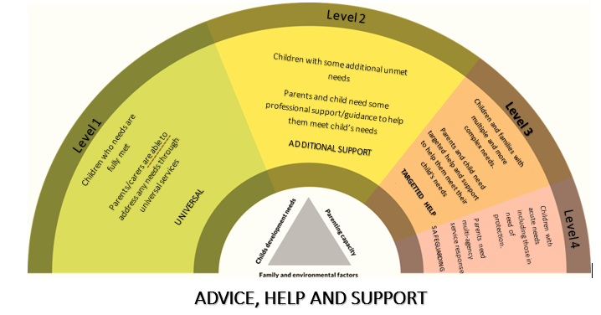

Early Help partnership collaboration and co-production

- Strengthening communities: development of our local preventative and Early Help offers across the six Worcestershire districts.
- Independence and resilience: Enabling families, children and young people from pre-birth to 18 years to achieve positive outcomes and access help and support when they need it. The right services at the right time in a range of ways.
- Relational: Whole family approach to create sustainable change rather than reacting to individual issues in isolation.
- Integration: We will develop a partnership approach to support the statutory and voluntary sector that is community based and ensures a consistent approach to the application of the Worcestershire levels of need guidance and has agreed response frameworks.
- Targeted: We target resources to those at risk of the poorest outcomes and work as a network of services to make every contact count reducing referrals for social work intervention and entry to care or criminal justice systems.
- Evidence of impact: Choosing interventions based on acknowledged evidence of what works and is accessible for our children, young people and their families. Identifying impact measures to ensure the Early Help offer is effective.
- Partnerships: Using our partnerships and relationships to build resilience empowerment and build capacity within neighbourhoods and communities.
- Enterprising: To develop new partnerships and funding opportunities both nationally and local to enable new Early Help developments that are innovative and meet the ever-changing needs of children and young people.
- Developing our shared workforce: We will collectively explore opportunities to develop our workforce together and this will be part of our shared approach. Training and learning events will be multi agency led across the county.
- Whole family working: Our approaches will be including wider family for children and young people recognising the importance of family and drawing on the child and young person’s own network of support, helping to create sustained changes.
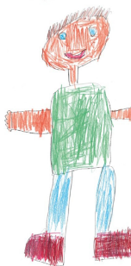

Our key priorities for 2022 - 2025

1) Embed Early Help across all agencies, partners and our workforce.
2) Worcestershire’s Early Help offer incorporates our response to the Covid recovery for children and young people including emotional health and wellbeing, education, poverty and additional vulnerabilities.
3) Development of our Worcestershire Early Help partnership offer across our district communities. Local services and support for children and young people.
4) Our accessibility to children and young people across our county recognising the need to ensure diversity and inclusion.
5) Our partnership engagement of parents / carers/ children and young people in multi-agency Early Help offers of help and support.
6) Developing opportunities for co-production and collaboration of Early Help support and services for children and young people with children, parents / carers, partners and communities.
7) Ensuring access to Early Help is seamless and well communicated without the need to be passed around agencies causing delay and families repeating their story.
8) The Worcestershire Early Help partnership will ensure the development of a coherent start for life offer available to all families, the development of Family Hubs and co-located services and Here2Help support.
9) The implementation of the new Integrated Care System, 0-25 disability agenda and youth violence strategy will all be integral to the Worcestershire Early Help partnership’s work and development.
10) Our partnership agreed impact measures to ensure we are delivering effective preventative and Early Help provision for children and young people, including the supporting families programme (AKA Troubled Families agenda) and the Holiday Activity and Food programme.
11) The Early Help partnership action plan will drive progress against this strategy and measure impact and outcomes for children and young people to ensure the Worcestershire Early Help strategy is effective.

Governance and accountability

The delivery of the Early Help strategy will be overseen by the Children and Young People’s Partnership. This partnership will receive regular updates on the progress of implementing the Early Help Strategy and any areas of challenge to this.
The Children and Young People’s Partnership is accountable locally to the Health and Wellbeing Board and provides an annual update on its progress as well as updates on specific aspects, such as child mental health throughout the year. These updates will also include an update on the implementation of the Early Help Strategy.
This strategy has a multi-agency action plan driving and shaping its implementation and is reviewed and progressed by the Early Help partnership in the quarterly meetings.

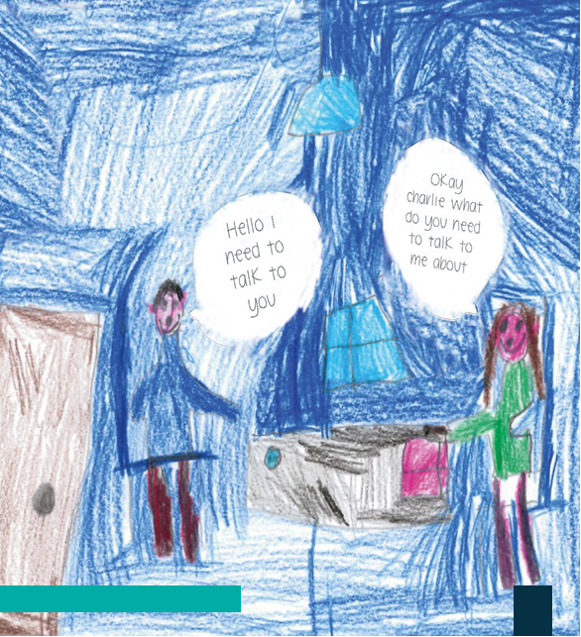

APPENDIX 1 – Glossy of terms in Early Help:

Early Help and Early Intervention – is language that is used to describe the process of identifying and intervening as soon as possible with families to help prevent issues from happening or escalating. This may be due to a specific need, incident(s) or vulnerability.
Early Help Assessment – A voluntary assessment undertaken by any professional or agency in contact with a child or their family. It is designed to identify needs at an early stage and enable suitable help and support to be put in place to address the identified needs. Worcestershire has an Early Help assessment which can be used by any agency or an agency may have their own which they use.
Early Help plan – this follows the Early Help assessment when the needs of the child and their family has been identified and this plan outlines what needs to happen and what help and support is available by whom and when. This allows us to review how things are going and anything we need to change and can involve the wider extended family.
Early Help review/ Team around the family meeting- both used to describe the meeting that reviews how the plan is working and agree next steps or amendments.
Early Help closure – This is the closure record that captures the impact and outcomes achieved by the family and what support was offered and how it made a difference.
Early Years – refers to children aged from 0-5 years of age.
Early years provider – relates to early education places for children under 5 years of age. This includes state – funded and private nurseries as well as child minders.
Education, Health and Care Plan (EHC plan) – This plan details the education, health and social care support that is to be provided to a child or young person who has special educational needs or a disability.
Graduated approach - A model of action an intervention in early education settings, schools and colleges to help children and young people who have special educational needs. The approach recognises that there is a continuum of special educational needs.
GET SAFE- This is the Worcestershire partnership approach to preventing, identifying and tackling child criminal exploitation and covers all levels of need for children and young people.
Holiday and Activities Fund (HAF program) – this is a government led programme to provide some activities and food to children who are on free school meals or identified as just about managing.
Health and Wellbeing Board - The wellbeing board acts as a forum where local commissioners across the NHS, social care and public health work together to improve the health and wellbeing of their local population and reduce health inequality.
Healthy Child Programme - The Healthy Child Programme covers pregnancy and the first five years of a child’s life, focusing on a universal preventative service that provides families with a programme of screening, immunisation, health and development reviews, supplemented by advice around health wellbeing and parenting.
Local Offer - Local authorities in England are required to set out their local offer information about provision they expect to be available across education health and social care for children and young people in their area who have special educational needs or are disabled, including those who do not have education health and care plans. Local authorities must consult locally on what provisions are for the local offer.
Reach 4 Wellbeing – aims to promote positive wellbeing, reach children and young people in their communities and reduce the stigma of mental health. They provide group programmes for children aged 5-18 years.
Start for Life Offer - To help build back better from the pandemic, and level up health and care provision for new families, The Best Start for Life: A Vision for the 1,001 Critical Days requires each Local Authority area to transform how families are supported through pregnancy and identify and publish its Start for Life offer for families.
Start4life app - NHS help and advice during pregnancy, birth and parenthood.
Supporting Families program– This is led across the country by the Department for Education (DfE) and is aimed at enabling families to get the help and support they need to address multiple disadvantages through a whole family approach delivered by the partnerships This was initially known as the Troubled Families programme in 2012.
Signs of Safety – This is an approach used in Worcestershire which is strengths based and enables families to help identify their own solutions to the challenges they face.
Starting Well Partnership Services– this is a range of services that provides universal and targeted support to children and young people and their families with the aim of improving life chances and reducing health inequalities.
Targeted – Targeting an intervention means it is aimed at a specific population with a specific need. For example, an intervention could be targeted at parents with mental health difficulties or young people who have experienced a trauma.
Universal – Universal programmes are aimed at everyone within the specified age range, recipients of the intervention don’t need to meet a criteria to access the programme. E.g., education, health services, Police.

For more information go to the Early Help website at: The Family Hub | Worcestershire County Council

