Worcestershire Safeguarding Children Partnership
Multi-agency safeguarding arrangements

Working together to enable children and young people to:
Get Safe – Stay Safe June 2019
(Updated Jan 2023)

Introduction

The Children and Social Work Act 2017 supported by guidance in Working Together 2018 set out requirements for each area to re-design safeguarding arrangements previously provided by Local Safeguarding Children Boards (LSCBs).
Responsibility for the design and implementation of the new arrangements rests with the three named Safeguarding Partners; the Local Authority, the Police and Clinical Commissioning Groups.
For Worcestershire the chief officers/executives for the three Safeguarding Partners are; Chief Executive; Worcestershire County Council
Chief Constable; West Mercia Police

Chief Executive; NHS Herefordshire and Worcestershire Integrated Care Board (ICB)
Working Together 2018 set out a requirement for local areas to publish their new multi-agency safeguarding arrangements by 29 June 2019 and implement them by 30th September 2019. Our multi-agency safeguarding arrangements have been in place since September 2019. Following a review, we are delighted to publish these updated arrangements on behalf of the children and young people in Worcestershire.

As a Partnership we will continue our commitment to safeguarding children together.

In our new arrangements the three named Safeguarding Partners; Local Authority, Police and ICB, will work together as an Executive Group coming together with the wider group of partners on a six- monthly cycle where the longstanding ethos of scrutiny, challenge and continuous improvement will continue to drive our activity to improve safeguarding arrangements for children and young people.

Key principles underpinning our new safeguarding arrangements include;

- Children and Young People are at the heart of what we do and we will make a positive difference to their lives
- We will work together with this as our collective responsibility
- We will have a culture of scrutiny and challenge
- We are a “learning partnership” and we will promote best practice
- We will share information in an effective way and use it to intelligently inform our work

Our Vision – Get Safe – Stay Safe

Our vision is to have in place multi-agency arrangements across our frontline services to enable children and young people to Get Safe and work together at a strategic level to enable them to Stay Safe.
Geographical area

The Worcestershire Safeguarding Children Partnership (WSCP) will cover the county of Worcestershire and as such is co-terminus with the area covered by Worcestershire County Council.

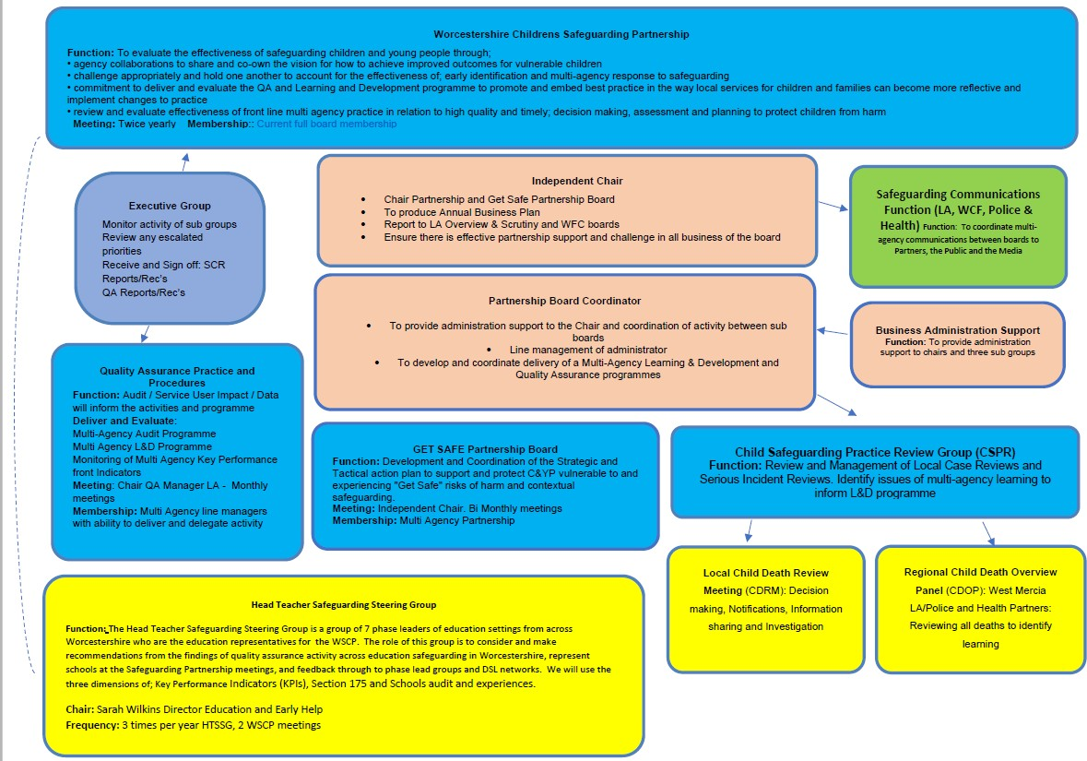It is recognised that the ICB cover this area and that the ‘footprint’ of West Mercia Police extends beyond Worcestershire.
The Worcestershire Safeguarding Children Board worked closely with all its members to plan our new arrangements. At our annual development day (March 19) a final decision was reached on our new arrangements.

We agreed the following key principals for our re-design:

  - Maintain an independent chair to bring cross partnership scrutiny and challenge to the way we work together
  - Streamlining of sub-groups and functions to reduce bureaucracy and focus on priority issues
  - Maintain fullest possible membership of partners outside the three key statutory partners
  - Deliver a co-ordinated Quality Assurance and Learning & Development programme

The new Worcestershire Safeguarding Children Partnership (WSCP) arrangements are set out in detail below with an agreed timetable to have the new arrangements in place by 30th September 2019.

The approach we have taken is to build on the existing strong and effective partnership in Worcestershire, retaining the best of the current arrangements and integrating new and innovative ways of partnership working.

Below is a visual representation of our new Worcestershire Safeguarding Children Partnership (WSCP) arrangements:

Governance and Scrutiny

Independent Chair

As a Partnership we will retain an independent chair. The Safeguarding Partners and the wider Partnership has decided to retain an Independent Chair who will provide challenge, scrutiny and strategic leadership to the WSCP as a whole, to the Executive Group and to the Get Safe sub-group.
The Chair will be expected to engage at a regional and national level, sharing best practice and identifying learning that contributes to improved outcomes in Worcestershire.

The Worcestershire Safeguarding Children Partnership will work with the Worcestershire Safeguarding Adults Board (SAB), particularly with regards to shared issues such as contextual safeguarding and transition, harmonising of sub-group activity and exploitation.
The Independent Chair will continue to work with the Health and Wellbeing Board and the Community Safety Partnerships to ensure effective partnership working and collaboration.
The Independent Chair will also report annually to the Management Board of Worcestershire Children First, Worcestershire County Council Overview and Scrutiny Committee; the Herefordshire and Worcestershire Integrated Care Board and West Mercia Police.
The WSCP will be supported by a re-designed Business Unit, which will work with the Independent Chair and the Executive Group to co-ordinate the activity of the sub-groups and publish a yearly report.
Residential homes for children

There are a wide range of private independent children’s homes and an internal residential provision. As part of our new arrangements we will establish a forum for Care Providers to come together with the three Statutory Partners in order to share information and coordinate services to children in the care of the local authority and those placed in our area by others.
There are no secure establishments in the county at this time. Worcestershire are part of the West Midlands regional Safe Centre bid currently being considered by the Department for Education (DfE).
WSCP Business Unit

Under the new arrangements the WSCP Executive Group, the Independent Chair and the wider Partnership will be supported by a Partnership Co-ordinator with administrative support.
The Co-ordinator will co-ordinate the activity of the Partnership, the Executive Group and sub- groups and will work with the Independent Chair to produce an Annual Report.
Working in Partnership

We recognise that the voice of children and young people should be at the heart of our work and the WSCP will work with children and young people, their families and advocates to ensure that their voice is heard and that it informs what we do.

We are strongly committed to ensuring we have wide representation from the statutory and voluntary sectors across Worcestershire.
The relevant agencies that will form the WSCP are listed in Appendix 1. In addition, each sub group of the partnership will have a strong multi-agency representation accountable for the day to day delivery of the agreed business plan.
Education has been a long-standing and valued member of multi-agency partnership working in Worcestershire with representatives of early years, primary, middle, secondary, further education, special schools and the independent sector all playing an active part in Board and sub-group activities over a number of years.
It is fully intended to maintain this engagement with all those elements remaining an integral part of the Partnership, both at the annual meetings and by active participation at the sub-groups.
We know information sharing is critical in effective multi-agency partnerships and the WSCP will continue to develop established frameworks produced under former arrangements so that relevant, timely and accurate data and key performance indicators are shared that help us understand the cross partner activity and effectiveness of our work from Early Help through to Child Protection.

WSCP - Partnership Board and Executive Group

The three Safeguarding Partners via their delegated representatives will work together as an Executive Group with overall accountability for safeguarding and promoting the welfare of children in Worcestershire. The Executive Group will also include the Independent Chair, other relevant partners as appropriate and the chairs of the three sub-groups.
This group will determine the Business Plan and priorities, sharing those with the wider Partnership and retaining responsibility for promoting and delivering the Plan.
The Executive Group will act as a strategic leadership group in overseeing the work of the sub- groups, work with relevant partners and disseminate learning from local and national reviews.
The Executive Group will have responsibility for ensuring that local thresholds for action are regularly reviewed and circulated for awareness among practitioners. Any issues that require resolution will be escalated through this Group and ultimately to the Independent Chair.

Sub-Groups of the Partnership Board

Quality Assurance Practice and Procedures (QAPP)

As a partnership we are committed to service development and consider ourselves a “learning partnership”.
With strong multi-agency representation our QAPP Sub-Group will deliver a multi-agency programme of Quality Assurance through; audits, understanding service user experience and monitoring of Key Performance Indicators. The findings from these activities, along with any identified area of learning from the Safeguarding Practice Review Sub-Group will inform the multi-

agency programme of learning.

This will include assessing the effectiveness of help, including early help, being provided to children and their families.
We will continue to work with other safeguarding partnerships in the West Midlands Region and across the country, sharing learning and best practice so that multi-agency training and working is effective and delivers positive change.

Get Safe – Exploitation of Children and Young People

As a Partnership we have identified that Contextual Safeguarding and the exploitation of children and young people as being a key priority area of safeguarding for us all.
'GET SAFE' is the Worcestershire Safeguarding Children Partnership's title for the identification and management of multi-agency support and protection for children and young people at risk of Gang- related activity, sexual Exploitation, Trafficking, modern day Slavery, Absent and missing, Forced marriage, honour based violence and female genital mutilation, and criminal Exploitation.

This sub-group will develop and co-ordinate the strategic and tactical action plan to support and protect children and young people at risk of or who are experiencing exploitation. Our action plan sets out a range of activities under the headings of: Prepare, Prevent, Protect and Pursue.
This group will be chaired by the Independent Chair of the WSCP and will include representation from across the statutory and voluntary sectors of the Partnership.
Get Safe will liaise closely with other key strategic multi-agency forums, including the Serious and Organised Crime Joint Action Group (SOCJAG) and the Community Safety Partnership, as well as undertaking a programme of meetings with the other Local Authorities within the West Mercia Police footprint to ensure our work on this agenda is well co-ordinated and that information sharing and cross border partnership working enables us to meet the challenges and vision set out by Government in its Serious Violence Strategy.
Head Teacher Education Safeguarding Steering Group
The Education Head Teacher Safeguarding Steering Group consists of representatives of the Worcestershire phases of education settings. The group quality assures the safeguarding work of the education sector across Worcestershire and provides a direct link for that work into the wider safeguarding partnership. The group uses key performance indicators, the Section 175 safeguarding audit returns and direct feedback from schools to understand both the effectiveness of safeguarding arrangements, and the resulting outcomes for children. This group is chaired by the Director for Education, Early Years, Inclusion and Education Place Planning.
Membership includes representatives from the following schools’ areas:
- Early Years
- First Schools
- Independent Schools
- Primary Schools
- Middle Schools
- Secondary Schools
- Further Education
- Special Schools
- Alternative Provision

Safeguarding Practice Reviews

A key responsibility for the WSCP will be to commission and publish child safeguarding practice reviews and our revised arrangements for this are outlined below.
The Safeguarding Practice Review Sub-Group will review and manage local case reviews, including rapid reviews of serious incidents, and will where appropriate recommend the commissioning of Child Safeguarding Practice Reviews. This group will liaise with the ICB and Public Health who are the new ‘Child Death Partners’ and who will assume responsibility for the Child Death Review Process from September 2019.
We are committed to working together to safeguard children and young people across the county and recognise that we are stronger working in partnership.
The WSCP has adopted the West Midlands Early Adopters process for undertaking Child Practice Reviews.
We believe the new arrangements outlined in this report will strengthen co-operation and make a significant contribution to keeping children safe in Worcestershire.
Child Safeguarding Practice Reviews: arrangements for commissioning and publishing child safeguarding practice reviews
The purpose of child safeguarding practice reviews at both local and national level is to identify improvements to be made to safeguard and promote the welfare of children.
At a national level responsibility for identifying learning from serious incidents lies with the Child Safeguarding Practice Review Panel (National Panel). The interaction between the local and national levels is still evolving and future developments will be monitored by the Executive Group and the Safeguarding Practice Review Sub-Group in Worcestershire.

Serious harm and notifications

16C (1) of the Children Act 2004 (as amended by the Children and Social Work Act 2017) states:

Where a local authority in England knows or suspects that a child has been abused or neglected, the local authority must notify the Child Safeguarding Practice Review Panel if:
- The child dies or is seriously harmed in the local authority’s area, or
- While normally resident in the local authority’s area, the child dies or is seriously harmed outside England.

The notification must be within 5 days of becoming aware of the incident. The local authority should also report this to the WSCP.
The local authority must also notify the Secretary of State and Ofsted where a looked after child has died, whether or not abuse or neglect is suspected.
Serious harm includes (but is not limited to) serious and/or long-term impairment of a child’s mental health or intellectual, emotional, social or behavioural development. It should also cover impairment of physical health. This is not an exhaustive list. When making decisions, judgment should be exercised in cases where impairment is likely to be long-term, even if this is not immediately certain.

Any notification of an incident referred to the National Panel will also be referred to the Safeguarding Practice Review Sub-Group for a local decision on whether the case:
- meets the criteria for a Child Safeguarding Practice Review
- whether the case may raise issues which are complex or of national importance

Decisions regarding local child safeguarding practice reviews

The criteria below will be used by the Safeguarding Practice Review Sub-Group in order to determine whether to carry out a local child safeguarding practice review by considering whether the case:
- Highlights or may highlight improvements needed to safeguard and promote the welfare of children, including where those improvements have been previously identified
- Highlights or may highlight recurrent themes in the safeguarding and promotion of the welfare of children
- Highlights or may highlight concerns regarding two or more organisations or agencies working together effectively to safeguard and promote the welfare of children
- Is one in which the Child Safeguarding Practice Review Panel have considered and concluded a local review may be more appropriate

Further criteria cover concern about the actions of one agency; the lack of any agency information; cases which involve a number of authorities where families have moved around and concern about the welfare of children in institutional settings.

Recommendations on whether to undertake reviews will be made by the Safeguarding Practice Review Sub-Group. The decision as to whether to undertake a review will be made by the Safeguarding Partners, but with appropriate scrutiny and challenge from Independent Chair.

Child safeguarding practice reviews will be a standing item at the quarterly meetings of the Executive Group. If it is considered that the case raises issues that are of national importance then the Executive Group will be informed in between the quarterly meetings. Decisions will be made transparently and the rationale communicated appropriately, including to families.

Rapid Review process

When a serious incident becomes known to the WSCP, the Safeguarding Practice Review Sub-Group will promptly undertake a Rapid Review of the case. Current guidance requires that the outcome of the Rapid Review should be reported to the National Panel within 15 working days.
The WSCP will aim to comply with this wherever possible bearing in mind the importance of ensuring there is a thorough multi-agency investigation to inform decision making. The aim of the review is to enable the WSCP to:
- gather the facts about the case, as far as they can be readily established at the time;
- discuss whether there is any immediate action needed to ensure children’s safety and share any learning appropriately;
- consider the potential for identifying improvements to safeguard and promote the welfare of children;
- decide what steps we should take next, including whether to commission a child safeguarding practice review, and make a recommendation to that effect to the three Safeguarding Partners.

Once the Rapid Review is complete, the WSCP will:

- Send a copy to the National Panel setting out the case for the decision made
- Share with the National Panel any thoughts on whether the case may raise issues which are complex or of national importance such that a national review may be appropriate, and on whether WSCP plan to carry out a child safeguarding practice review
- Make the National Panel, the Department for Education and Ofsted aware of the decision to initiate/publish child safeguarding practice reviews

If the National Panel does decide to undertake a national child safeguarding practice review, the WSCP will take this into account when making a final decision on whether to undertake a local child
safeguarding practice review of any case covered by a national review.

Local reviews

On behalf of the WSCP, the Safeguarding Practice Review Sub-Group will commission and supervise reviewers for local reviews, taking into account whether the reviewer has relevant professional knowledge, recognition of the complexity in which practitioners work together, understanding of practice at the time rather than applying hindsight, effective communication skills and whether there is a conflict of interest.
A methodology will be agreed that ensures the review is proportionate and is focused on learning. Working with the reviewer, the Safeguarding Practice Review Sub-Group will be responsible for overseeing the quality of the review, ensuring practitioners are fully involved and that families have the opportunity to contribute.
The final report will include recommended improvements and an analysis of any systemic or underlying reasons why actions were taken or not in respect of matters covered by the report.
The WSCP is committed to publishing reviews whenever appropriate, but will always consider the potential impact on a child, their family or others involved in the case prior to publication.
A copy of the full report , or if applicable a learning summary, will be sent to the National Panel, Ofsted and the Secretary of State for Education no later than seven working days before the date of publication.
Whenever practicable, a review should be completed and published no later than six months from the date of the decision to initiate the review. Where other proceedings may have an impact on or delay publication the Independent Chair will inform the National Panel and the Secretary of State of the reasons for the delay. The rationale for any decision not to publish the full report will be communicated to the National Panel and the Secretary of State.
Learning will be disseminated and corrective action will be taken at the earliest point and not wait until publication or completion of the review.
Child Death Review arrangements

It has been agreed between the Safeguarding Partners and Child Death Review Partners that responsibility for child death arrangements in Worcestershire will transfer to Public Health and the ICB.
The details for the formal handover are being finalised and the new arrangements will be published by Public Health Worcestershire at: http://www.worcestershire.gov.uk/downloads/file/11281/child_death_review_plan

The new arrangements will include details as to how the Child Death Review Co-ordinator will link in to the WSCP via the Safeguarding Practice Review Sub-Group and the Partnership Co-ordinator to ensure that any child deaths involving issues of safeguarding are brought to the attention of the WSCP in a timely and appropriate way.

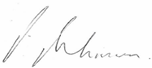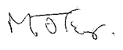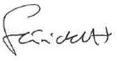Funding Arrangements

Working Together 2018 provides guidance as to how local safeguarding arrangements might be funded in an equitable way. We have made a decision to fund our arrangement through contributions from the three statutory partners and to have an equitable but not equal split between those agencies. New funding arrangements will come into effect October 2019 in line with the new partnership arrangements.
Review

These arrangements will be reviewed again by September 2024.

Signatories:

Paul Robinson Chief Executive: Worcestershire County Council

Signature
Martin Evans Assistant Chief Constable: Local Policing, West Mercia Police

Signature

Simon Trickett Chief Executive: NHS Herefordshire and Worcestershire

Signature

28 June 2019

Appendix 1

The three Safeguarding Children Partners

Chief Constable, West Mercia Constabulary-
Chief Executive, NHS Herefordshire and Worcestershire Integrated Care Board
Chief Executive, Worcestershire County Council Chief Executive, and delegated representatives

Relevant Agencies

Health:
Herefordshire and Worcestershire Health & Care NHS Trust
Worcestershire Acute Hospitals NHS Trust
West Midlands Ambulance NHS Trust
NHS England (NHSE)
Worcestershire County Council:
Adult Social Care Public Health
Social Care and Safeguarding, Worcestershire Children First

Education:
FE Colleges First Schools Middle Schools
Secondary Schools Special Schools Independent Schools Early Years Providers

District Councils
Herefordshire and Worcestershire Fire and Rescue Service
Herefordshire & Worcestershire Youth Offending Service

CAFCASS
Community & Voluntary Sector (Young Solutions)

National Probation Service
Community Rehabilitation Company
Housing Providers

